INTERNATIONAL WORLD TB DAY 2008
As the previous years, IDENTITY,MERGE AND ACTION-AIM celebrated International World TB with former and present TB patients, with school teachers, other health practitioners,nursing students and AIM’s health team.
In total 135(67% females and 33%) participated in the celebration.

Program organized with the following components:
- 1 km rally with banners had slogans about the need and importance of TB awareness.
- Talk by the different TB specialists about TB.
- Display of TB symptoms with paper charts by LHV students.
- Dialogues by the TB former and present TB patients.
- Explanation of AIM’s TB awareness and treatment program
- How AIM treating TB patients with DOTS therapy?
For more information: aimngo@brain.net.pk

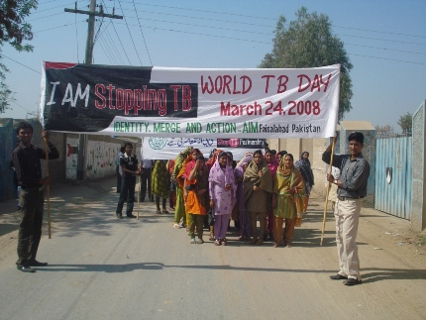

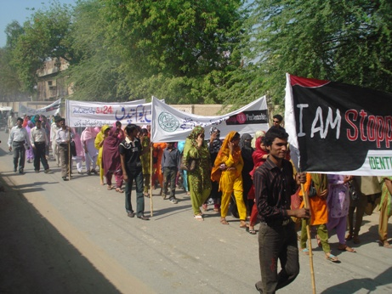
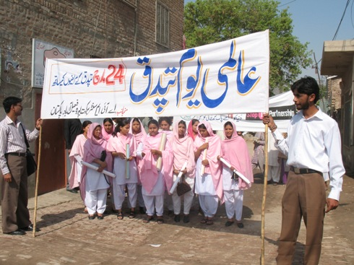

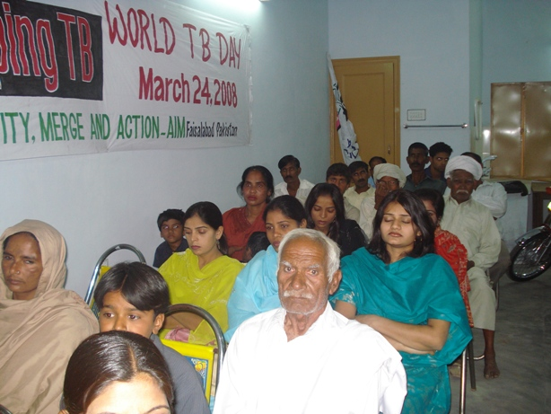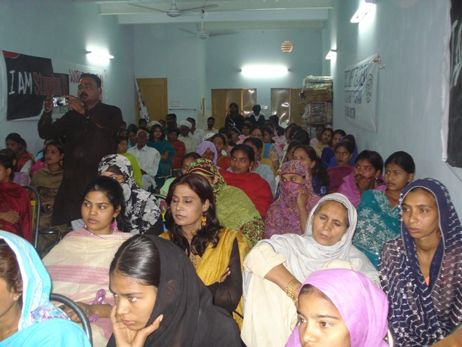
Girls in LHV(Lady Health Visitor) training program by AIM educating patients about TB with charts
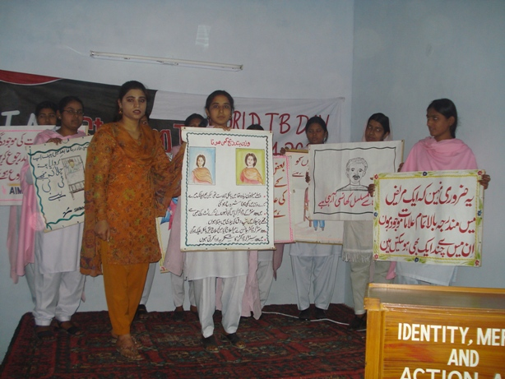

Dr.Ajmal Hussain (Chest Specialist) explain the medical background, importance of sputum +ve patients and precautions.


